**Experiment 1:**

Loss: hinge

Cost: ${\left|\left|x-z\right|\right|}_{2}^{2}$

F(x) regular classification accuracy = 82%

F(delta(x)) test accuracy = 69%

F’(delta(x)) test accuracy = 82%

F’(x) test accuracy = 65%

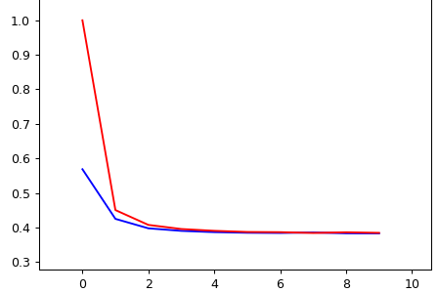 F’

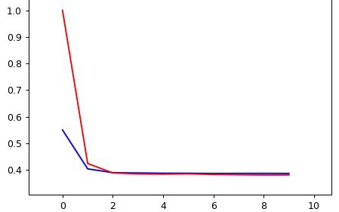F

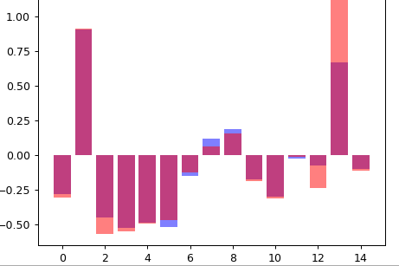F’ parameters (blue) vs F parameters (red)

**Experiment 2:**

Loss: hinge

Cost: $〈z-x, v〉 s.t v= [-1,-1,-1,-1,-1,-1,-1,1,1,0.1,1,0.1,0.1,1,0.1]$

F(x) regular classification accuracy = 82%

F(delta(x)) test accuracy = 52%

F’(delta(x)) test accuracy = 63%

F’(x) test accuracy = 52%

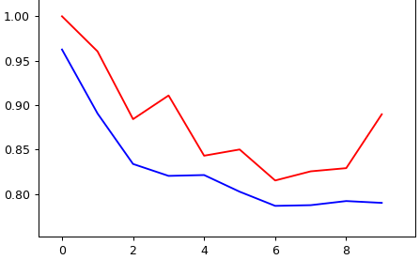F’

F

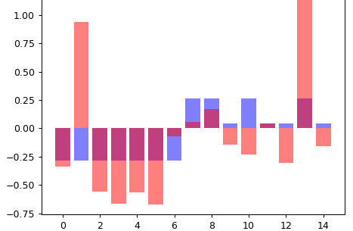

**Experiment 3:**

Loss: hinge

Cost: $10*〈z-x, v〉$ $$s.t v= [-1,-1,-1,-1,-1,-1,-1,1,1,0.1,1,0.1,0.1,1,0.1]$$

$$-2≤x≤2$$

F(x) regular classification accuracy = 82%

F(delta(x)) test accuracy = 49%

F’(delta(x)) test accuracy = 64%

F’(x) test accuracy = 63%

Weird X’ values:

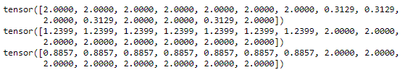

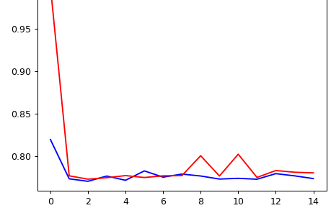F’

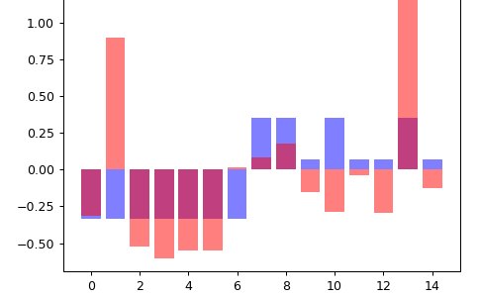

**Experiment 4:**

Loss: hinge

Cost: $\left(1-ϵ\right)∙〈z-x, v〉 +ϵ∙{\left|\left|x-z\right|\right|}_{2}^{2}$ $$s.t v= \left[-1,-1,-1,-1,-1,-1,-1,1,1,0.1,1,0.1,0.1,1,0.1\right] \\ epsilon=0.3$$

$$-2≤x≤2$$

F(x) regular classification accuracy = 84%

F(delta(x)) test accuracy = 57%

F’(delta(x)) test accuracy = 83%

F’(x) test accuracy = 49%

Weird X’ values:

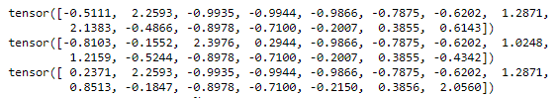

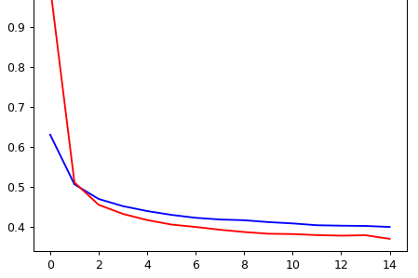F’

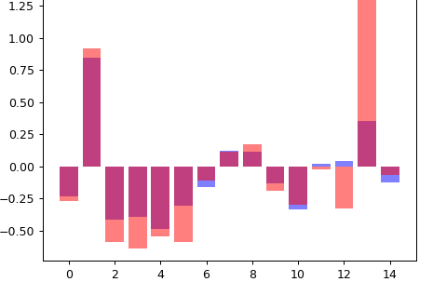

**Experiment 5:**

Loss: hinge

Cost: $\left(1-ϵ\right)∙〈z-x, v〉 +ϵ∙{\left|\left|x-z\right|\right|}_{2}^{2}$ $$s.t v= \left[-1,-1,-1,-1,-1,-1,-1,1,1,0.1,1,0.1,0.1,1,0.1\right] \\ epsilon=0.1$$

$$-2≤x≤2$$

F(x) regular classification accuracy = 82%

F(delta(x)) test accuracy = 54%

F’(delta(x)) test accuracy = 79%

F’(x) test accuracy = 50%

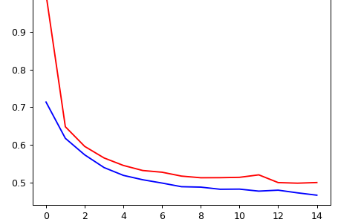F’

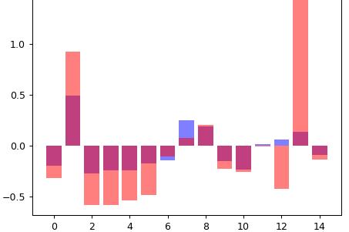

**Non-linearity (and x moves only when f(x) = -1):**

Tried

$$delta\left(x\right)= {argmax}_{z}\left\{f\left(x\right)– sigmoid\left(f\left(x\right)\right)*c\left(z, x\right)\right\} \\ delta\left(x\right)= {argmax}_{z}\left\{f\left(x\right)– e^{f\left(x\right)}*c\left(z, x\right)\right\} \\ delta\left(x\right)= {argmax}_{z}\left\{f\left(x\right)– f\left(x\right)*c\left(z, x\right)\right\}$$

none of them were dpp (a rule-set for fast solving parametrized problems)

<https://www.cvxpy.org/tutorial/advanced/index.html#dpp>

**Ideas for next step:**

1. Regression: Train with loss:

$$L=E_{x,y\sim D}\left[MSE\left(f\left(Δx\right), y\right)+λ∙\left(f\left(x\right)-f\left(Δx\right)\right)\right] \\ OR \\ L=E_{x,y\sim D}\left[MSE\left(f\left(Δx\right), y\right)-λ∙f\left(Δx\right)\right] \\ Δx= argmax_{z}\left\{f\left(z\right)-c\left(z, x\right)\right\}$$

*Red f is trained in a non-gaming environment*

1. Classification: Train with loss:

$$L=E_{x,y\sim D}\left[ZERO_ONE\backslash HINGE\left(f\left(Δx\right), y\right)+λ∙\min_{f\left(x^{'}\right)=1}{c\left(x, x^{'}\right)}\right] \\ Δx= argmax_{z}\left\{f\left(z\right)-c\left(z, x\right)\right\} \\ ∀a, b 0≤c\left(a,b\right)≤2$$

Findings:

With cost = ${\left|\left|x-z\right|\right|}_{2}^{2}$

$$∀x∈X :Δx= x^{'}-x=c (const) \\ =>∀\frac{Δx\left(i\right)}{w\left(i\right)}≈\frac{Δx\left(j\right)}{w\left(j\right)}$$

**Experiment 6: on synthetic data**

Loss: hinge

Cost: ${\left|\left|x-z\right|\right|}_{2}^{2}$

Gain: $\log\left(f\left(x\right)+1\right)$

F(x) regular classification accuracy = 99%

F(delta(x)) test accuracy = 50%

F’(delta(x)) test accuracy = 89%

F’(x) test accuracy = 77%

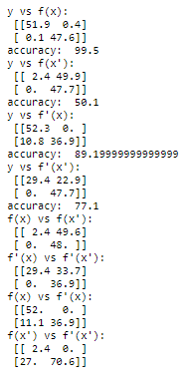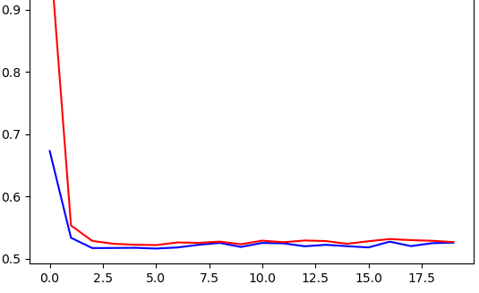F’

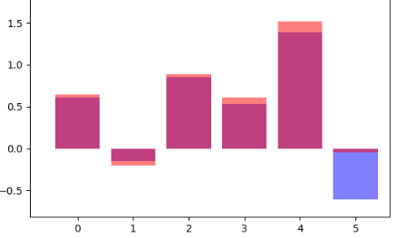

**Experiment 7:**

Loss: hinge

Cost: ${\left|\left|x-z\right|\right|}_{2}^{2}$

Gain: $\log\left(f\left(x\right)+1\right)$

F(x) regular classification accuracy = 85%

F(delta(x)) test accuracy = 58%

F’(delta(x)) test accuracy = 84%

F’(x) test accuracy = 83%

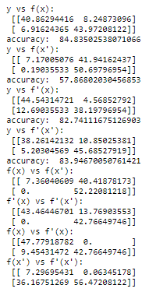 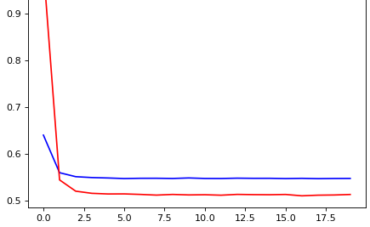F’

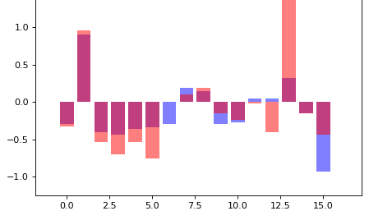

Findings:

X’s move in the direction of w. each one with a unique difference